11. THERMAL BRIDGING

IN THIS CHAPTER

11.1 Overview of thermal bridging

11.2 Modelling thermal bridging

11.3 Default steel framing specifications

11.4 Modelling thermal breaks

11.5 NatHERS treatment of airspaces adjacent to framing

11.6 Additional constructions modelling guidance

11. THERMAL BRIDGING

This chapter explains thermal bridging and includes details on how to model thermal bridges in walls, floors, ceilings and roofs.

It also explains thermal breaks and outlines the requirements for how to model them, including the default values to use when thermal break specifications are not included in design documentation.

|  |
| --- |
| **Summary of key requirements**  This handbook is intended to be a helpful resource for all assessors. When conducting assessments, assessors must still follow the requirements of the current NatHERS Technical Note and the relevant state or territory requirements.  **11a** Thermal bridging only applies to repeating steel frame elements where insulation is interrupted. Thermal bridging is applied in walls, ceiling and floors as outlined in Table 6 of the NatHERS Technical Note.  **11b** Assessors must model thermal bridging that occurs in the design documentation in accordance with the software’s instructions. If the software has the functionality to select specific metal framing specifications, these may be used to apply thermal bridging to the relevant elements. When steel framing details are not supplied and if the software has the functionality, assessors must model the default steel framing specifications outlined in Table 7 of the NatHERS Technical Note.  **11c** Thermal break materials must have a minimum R-value of R0.2 as specified by the 2022 National Construction Code (NCC).  **11d** Assessors must model thermal breaks according to the NCC 2022 requirements and as specified in the design documentation in accordance with the software’s instructions. When thermal breaks are required as per the NCC 2022 provisions but are not specified in the design documentation, assessors must model the default value R0.2 and refer to Table 8 of the NatHERS Technical Note.  **11e** Assessors must enter an additional R0.16/air gap to thermally bridged construction types detailed in this chapter whilst referring to individual software guidance notes for specific modelling instructions. |

**11.1 Overview of thermal bridging**

11.1.1 What is a thermal bridge?

A thermal bridge, also known as a heat bridge or a cold bridge, is a weak point in part of a building envelope that enables heat or cold to pass directly through the envelope. It is the thermal path of least resistance that typically occurs where there is an interruption to insulation caused by a structural element that has a higher thermal conductivity than the surrounding material.

Any solid material can act as a thermal bridge. It can be a single structural element – a steel beam for example. It can also be a combination of elements that are in direct contact with each other – for example, external cladding fixed directly to a structural frame that itself is directly fixed to the internal lining or is open to the internal environment. See Figure 11-1 below.

The bridge’s thermal conductivity will determine how much heat or cold it can transfer. For example, steel has a higher thermal conductivity than common structural timber so it creates a stronger pathway of least resistance for heat or cold to transfer.

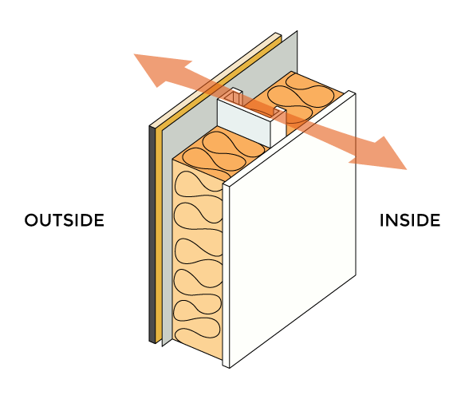

***Figure 11-1:*** *Direct-fixed steel-framed wall showing the thermal path of least resistance through the steel frame, with no thermal break (non-compliant construction).*

11.1.2 Impacts of thermal bridging

Thermal bridges can reduce the energy efficiency of a building by transferring heat or cold into or out of a building. This can increase the energy needed to heat or cool the building.

Thermal bridges can also cause condensation when warm moist inside air meets the cold surface of the bridge. If the temperature of the thermal bridge material falls below the dewpoint, moisture can condense on the inner surface. This can lead to mould growth and, if excessive, may also damage structural elements within a building over time.

In the case of a direct-fix clad, insulated steel-framed external wall (seen in Figure 11-2 below), the temperature of the internal plasterboard, which is in direct contact with the steel frame, will be similar to the outside temperature. On a cold day, the temperature of this section of the plasterboard may dip below the dewpoint of the indoor air causing condensation to form on the plasterboard.

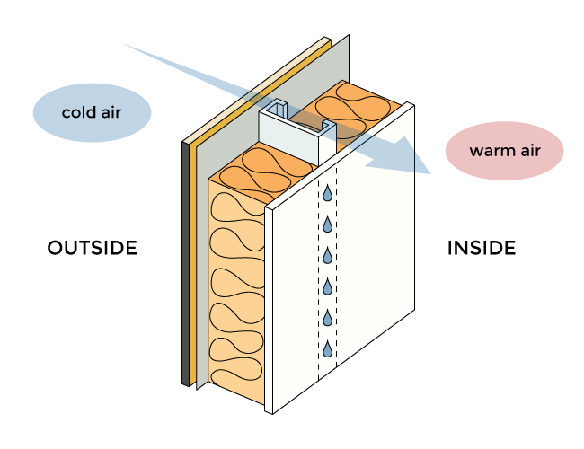

***Figure 11-2:*** *Condensation may form on the internal lining if thermal bridging is not mitigated.*

11.1.3 What is a thermal break?

A thermal break or a thermal barrier is the opposite of a thermal bridge. It includes any material that interrupts the conduction of heat or cold between building elements. Thermal breaks counteract the effects of thermal bridging, reducing heat loss and/or gain and subsequently improving the overall energy efficiency of a building. See Figure 11-3 and Figure 11-4 below.

As defined by the NCC 2022, thermal breaks are materials with an R-value greater than or equal to R0.2 that are installed between and separate the cladding from the frame. This includes, but is not limited to:

* materials such as timber battens greater than or equal to 20mm thick
* expanded polystyrene strips greater than or equal to 12mm thick
* continuous thermal breaks such as polystyrene insulation sheeting deemed to achieve an R-value greater than or equal to R0.2.

The NCC provisions require thermal breaks for walls to be installed at all points of contact between the external cladding and the metal frame. This is in scenarios when the wall does not have a wall lining or has a wall lining that is fixed directly to the metal frame and is clad with weatherboards, fibre-cement or the like, or metal sheeting fixed to the metal frame. See Figure 11-3 below

The NCC provisions require thermal breaks for roofs to be installed between the metal sheet roofing and its supporting metal purlins, metal rafters or metal battens. This is in circumstances where the metal sheet roofing is directly fixed to metal purlins, metal rafters or metal battens and does not have a ceiling lining, or has a ceiling lining fixed directly to those metal purlins, metal rafters or metal battens. See Figure 11-4 below.

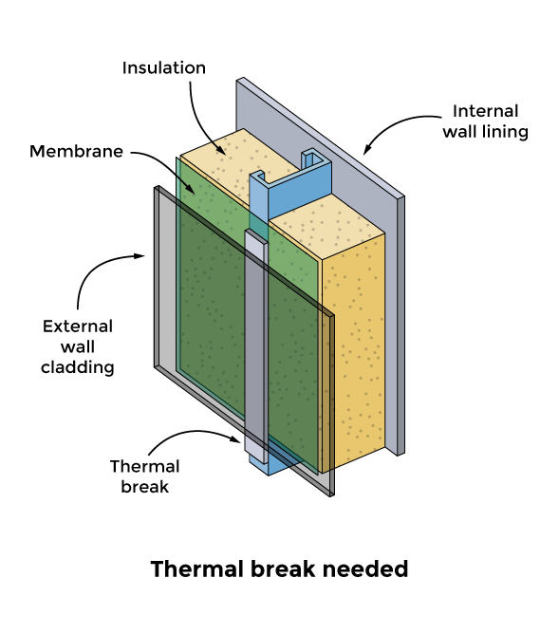

***Figure 11-3:*** *A minimum R0.2 thermal break is required to be installed at all points of contact between the external cladding and the metal frame when lightweight cladding is attached to the same steel member as the internal lining in an insulted steel framed wall. Image source: The NCC Housing energy efficiency Handbook provided by the Australian Building Codes Board under the CC BY 4.0 licence, March 2023.*

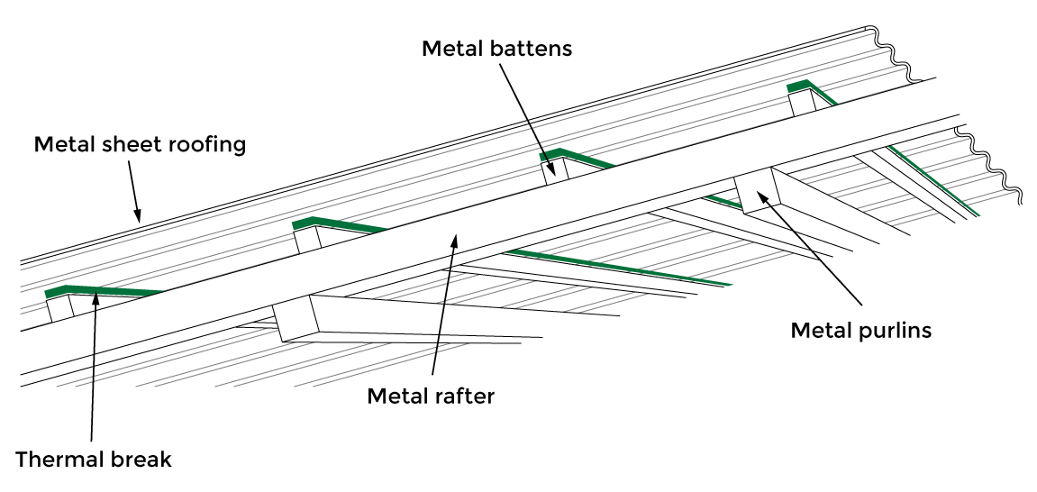

***Figure 11-4:*** *A minimum R0.2 thermal break in a roof construction (insulation not shown). Image source: The NCC Housing energy efficiency Handbook provided by the Australian Building Codes Board under the CC BY 4.0 licence, March 2023.*

11.1.4 Thermal bridging in NatHERS

NatHERS has been modified to include a thermal bridging function to align with the NCC 2022 requirements. The new function was developed using CSIRO's Thermal Bridging Implementation in AccuRate Report (2023) and Thermal Bridging Report (2020). Thermal bridging impacts are based on the calculation method outlined in standard NZS 4214:2006 *Methods of determining the total thermal resistance of parts of buildings*.

As guided by the NCC 2022 requirements, the application of thermal bridging only applies to repeating steel-framed elements. It does not apply to timber-framed constructions. The performance of steel-framed buildings must now achieve a similar performance to timber-framed buildings; i.e. thermal bridging calculations will be based on a comparison to timber framing as a benchmark rather than the actual performance of steel frames. Assessors will have the option of adding thermal breaks and/or improving other elements of the home’s design to offset any negative impacts associated with thermal bridging. The diagrammatic images below in Figure 11-5 show examples of repeating steel frame elements for the roof, wall and floor.

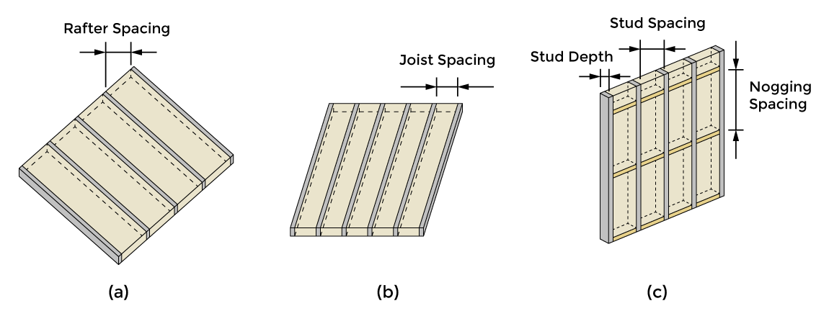

***Figure 11-5:*** *Diagrammatic illustrations of thermal bridging in insulated, repeating steel frame elements for (a) roof without a roof cavity, (b) floor or ceiling with a roof cavity and (c) wall.*

**11.2 Modelling thermal bridging**

Thermal bridging modelling in NatHERS applies to repeating steel frame elements only where insulation is interrupted by the steel framing. As a minimum, assessors must apply thermal bridging to the steel-framed building elements outlined in Table 11-1 (Table 6 in the NatHERS Technical Note) and illustrated in Figures 11-6 and 11-7. Assessors may also model the effects of thermal bridging for additional features if they exist, to improve the thermal modelling accuracy and if the software allows.

**Table 11-1**

|  |  |
| --- | --- |
| **Building element** | **When to apply thermal bridging** |
| External walls (Class 1) | Apply to all  Ignore external walls of attached unconditioned garage |
| Apartment walls (Classes 2 & 4) | Apply if adjacent to non-neighbour spaces such as stair wells, corridors, car parks and other shared public spaces  Ignore if adjacent to neighbour |
| Internal walls | Apply if adjacent to:   * unconditioned garages * roof spaces * subfloor zones   Ignore all other internal walls |
| Ceilings | Apply to ceilings:   * below a roof space * directly attached to a roof (e.g. flat, skillion, cathedral) * non-neighbour public areas   Ignore if adjacent to another zone (excluding roof space) |
| Floors | Apply to suspended floors above:   * outside air (including sub-floors) * unconditioned garage * non-neighbour public area   Ignore if:   * in-between floors of multi-level Class 1 building * adjacent to neighbour zone |

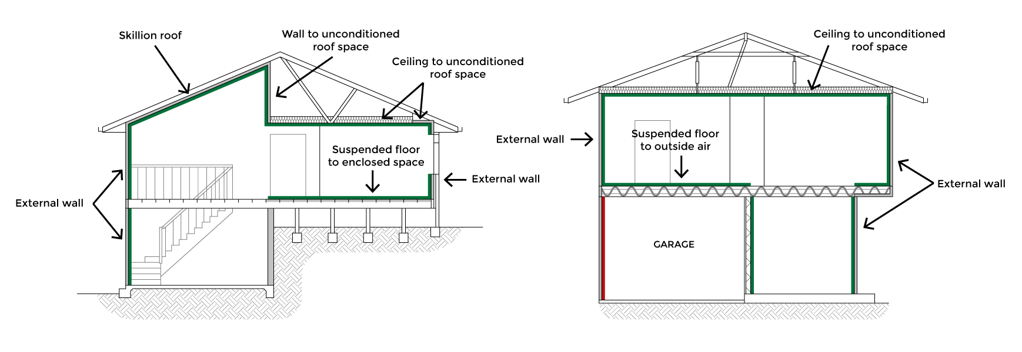

***Figure 11-6:*** *Class 1 examples of steel frame building elements that require thermal bridging to be modelled outlined in green.*

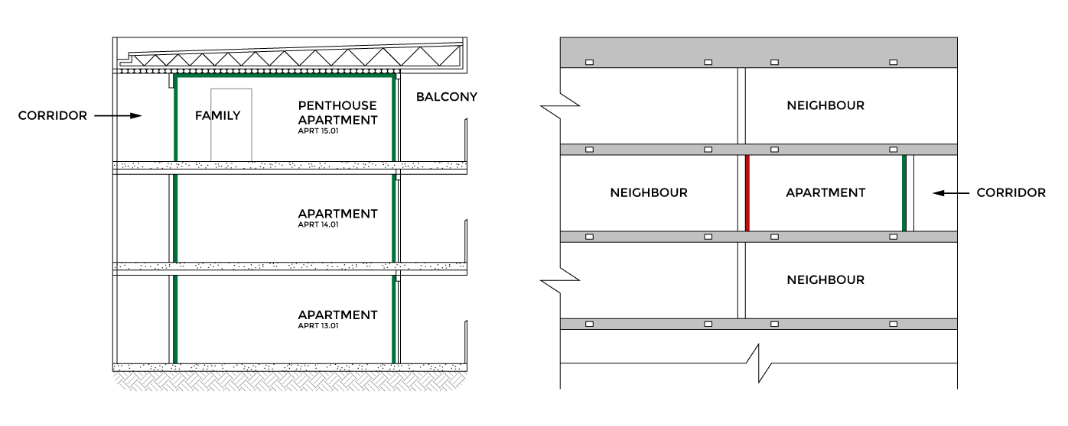

***Figure 11-7:*** *Class 2 & 4 examples of building elements that require thermal bridging to be modelled outlined in green.*

**11.3 Default steel framing specifications**

Assessors must model thermal bridging that occurs in the design documentation in accordance with the software’s instructions. If the software has the functionality to select specific metal framing specifications, these may be used to apply thermal bridging to the relevant elements. When steel framing details are not supplied and if the software has the functionality, assessors must model the default steel framing specifications outlined in Table 11-2 (Table 7 of the NatHERS Technical Note).

**Table 11-2**

| Building feature | Frame element | Steel frame dimensions |
| --- | --- | --- |
| Ceiling/roof without roof cavity | Rafter | 200 x 75 mm |
| Rafter spacing | 900 mm |
| Flange width | 75mm |
| Base metal thickness | 1.5 mm |
| Ceiling with roof cavity elements – raftered roofs with concealed rafters or horizontal ceilings  Apply to edge batts as well as centre/non-edge batts | Joist | 90 x 40 mm |
| Joist spacing | 900 mm |
| Flange width | 40 mm |
| Base metal thickness | 0.75 mm |
| Wall | Stud | 90 x 40 mm |
| Stud spacing | 600 mm |
| Flange width | 40 mm |
| Base metal thickness | 0.75 mm |
| Nogging dimensions | 90 x 40 mm |
| Nogging spacing | 1200 mm |
| Floor | Joist | 100 x 50 mm |
| Joist spacing | 450 mm |
| Flange width | 50 mm |
| Base metal thickness | 1.5 mm |

Flange width and base metal thickness measurements are illustrated in Figure 11-8 below.

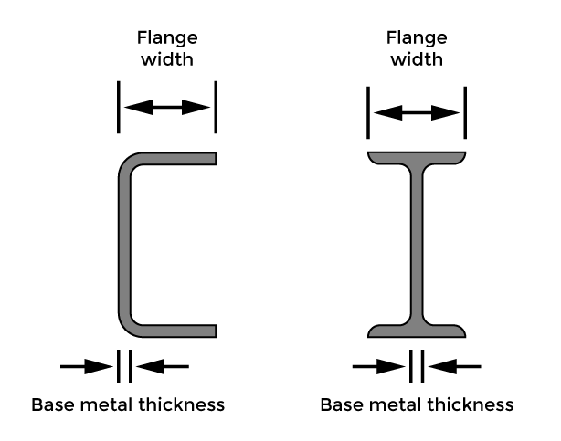

***Figure 11-8:*** *Flange width and base metal thickness measurements.*

**11.4 Modelling thermal breaks**

Thermal breaks can only be modelled after thermal bridging has been applied. As per the NCC 2022 requirements, thermal breaks must have an R-value greater than or equal to R0.2.

Assessors must model any thermal breaks specified in the design documentation in accordance with the software’s instructions.When thermal breaks are not specified in the design documentation, assessors must model the default values as specified in Table 11-3 (Table 8 from the NatHERS Technical Note).

**Table 11-3**

| **Element** | **Construction** | **Thermal break minimum R0.2[1] [2]** | **Air gap R0.16[3]** |
| --- | --- | --- | --- |
| External walls | Cavity[4] | No | Yes |
| Lightweight clad[5] (direct fixed to the same insulated steel member as the wall lining, or does not have a wall lining)[6] | Yes | No |
| Lightweight clad (battened out by secondary members fixed perpendicular to the frame) | No | Yes |
| Internal walls to unconditioned space/s | Cavity | No | Yes |
| Lightweight cladding (direct fixed to the same insulated steel member as the wall lining, or does not have a wall lining)[7] | Yes | No |
| Lightweight cladding (battened out by secondary members fixed perpendicular to the frame) | No | Yes |
| Metal sheet roofs | Above attic space | No | No |
| Skillion or cathedral roof that is directly fixed to metal purlins, metal rafters or metal battens and does not have a ceiling lining or has a ceiling lining fixed directly to those metal purlins, metal rafters or metal battens | Yes | Yes  1 x R0.16 if roof battens are present  1 x R0.16 if ceiling battens are present |
| Ceilings | Ceilings below attic spaces  (ceiling battens perpendicular to the frame) | No | Yes |
| Floors | Suspended floor above and exposed to an enclosed subfloor space e.g. no bottom lining | No | Yes |
| Suspended floor above unconditioned garage, outdoor air or non-neighbour | No | No |

**11.5 NatHERS treatment of airspaces adjacent to framing**

To align NatHERS modelling with established thermal bridging calculation methods, assessors must enter an additional R0.16 air gap to the following, referring to individual software guidance notes for specific modelling instructions. See Table 11-3 above (Table 8 from the NatHERS Technical Note):

**For walls:**

Apply an R0.16/air gap option to any thermally bridged external cavity walls[8] or thermally bridged internal cavity walls adjacent to an unconditioned garage or roof spaces. See Figure 11-9 below.

Apply an R0.16/air gap option to any lightweight clad[9] wall construction where the internal or external cladding is not directly fixed to the main steel frame, for example fixed via secondary metal battens perpendicular to the frame. See Figure 11-9 below.

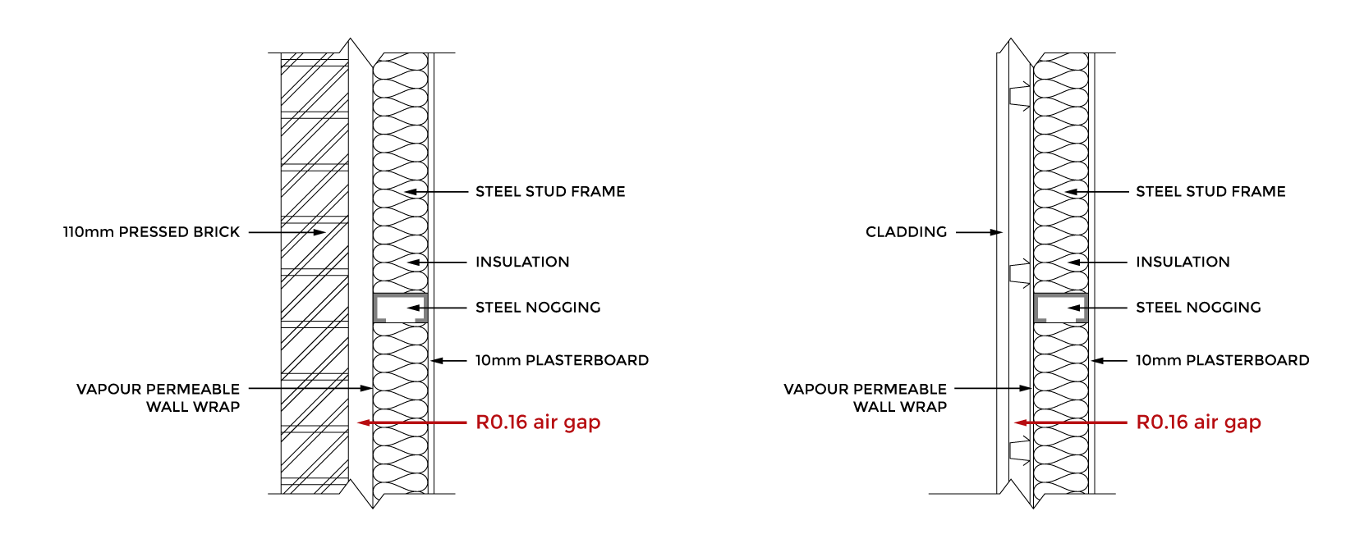

***Figure 11-9:*** *Modelling air gaps in steel-framed brick veneer and battened out lightweight clad walls.*

**For roofs:**

**Skillion or cathedral roof** – if available in the software apply an R0.16 air gap option if metal roof battens are shown in the design documentation. If available in the software apply an R0.16 air gap if metal ceiling battens are shown in the design documentation. See Figure 11-10 below.

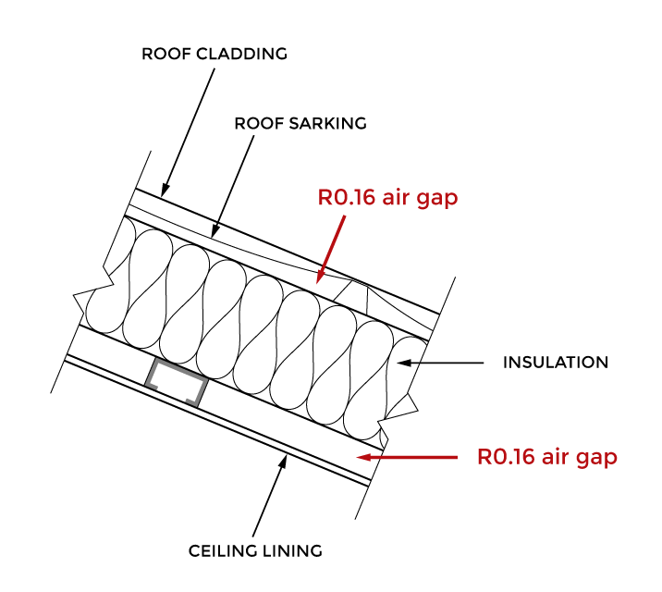

***Figure 11-10***

**Ceiling with unconditioned roof space above** – if available in the software apply an R0.16 air gap if secondary metal ceiling battens are shown in the design documentation. See Figure 11-11 below.

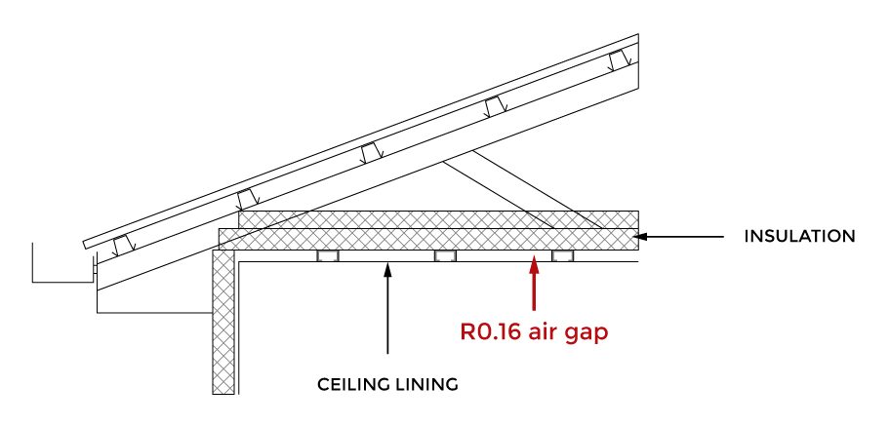

***Figure 11-12***

**For floors:**

If available in the software apply the R0.16/air gap option to any thermally bridged suspended floor above and exposed to an enclosed subfloor space, e.g. no bottom lining. This is to take account of the benefit provided by the sub-floor airspace in reducing thermal bridging of the frame. See Figure 11-12 below.

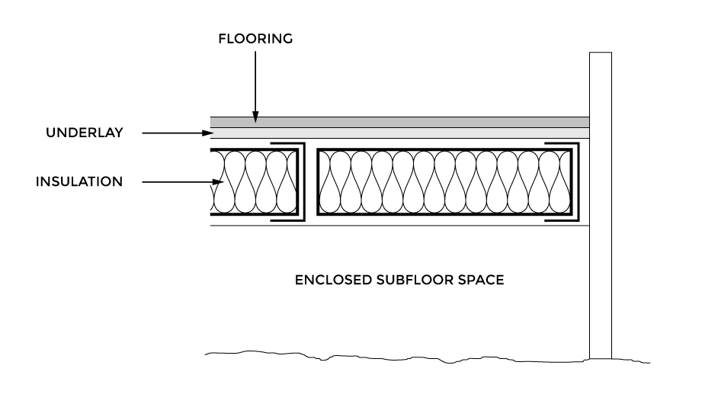

***Figure 11-12***

**11.6 Additional constructions modelling guidance**

Continuous insulation/continuous thermal break directly adjacent to and touching the insulated steel frame

If continuous insulation is applied directly adjacent to and touching the steel frame, this should currently be modelled by:

* + - 1. modelling the insulation according to the software’s instructions, e.g. as a separate construction layer, and
      2. ticking the thermal break box R0.2.

Roof blankets

Roof blankets do not currently need to be modelled for thermal bridging.

1. Thermal breaks are materials with an R-value greater than or equal to R0.2 installed at all points of contact between the external cladding and the frame. This includes, but is not limited to, materials such as timber battens greater than or equal to 20 mm thick, expanded polystyrene strips greater than or equal to 12 mm thick or continuous thermal breaks such as polystyrene insulation sheeting greater than or equal to R0.2.
2. Minimum R0.2 thermal break required in accordance with NCC 2022.
3. If the software has the functionality
4. E.g. masonry or brick veneer
5. Lightweight cladding includes weatherboard, fibre-cement or metal clad.
6. This construction type is not compliant with NCC 2022
7. This construction type is not compliant with NCC 2022
8. For example masonry or brick veneer
9. Lightweight cladding includes weatherboard, fibre-cement or metal clad