Appendix A Example time series

Example NatHERS time series for **Armidale**, showing temperature, dew point, wind speed, global and direct radiation, and annual percentiles (red lines) to assess consistency. Points in red are spatial interpolates, used only if required.

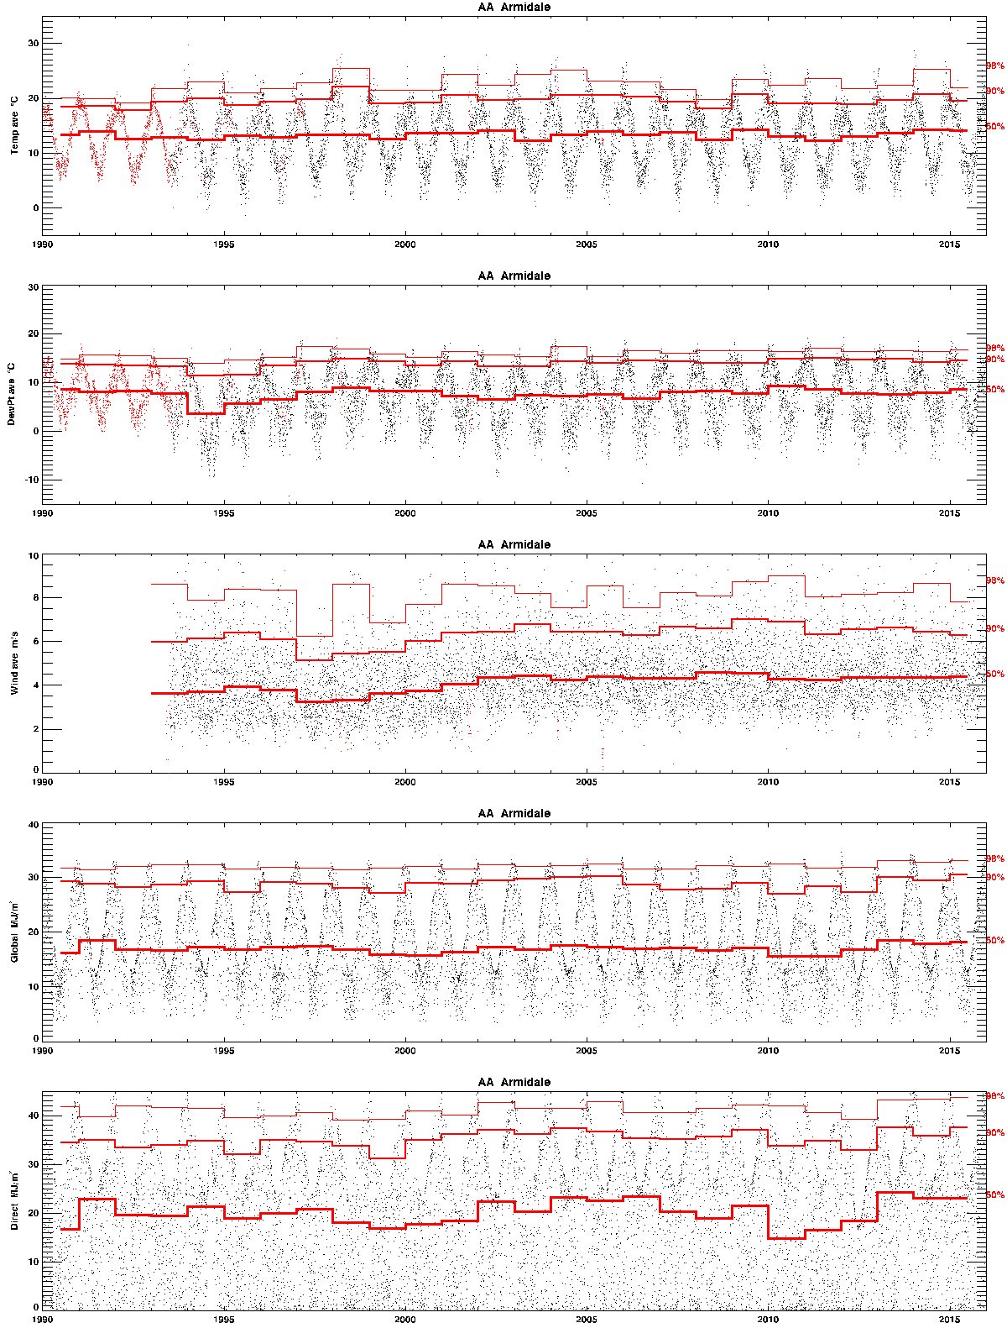

As above for **Albany**.

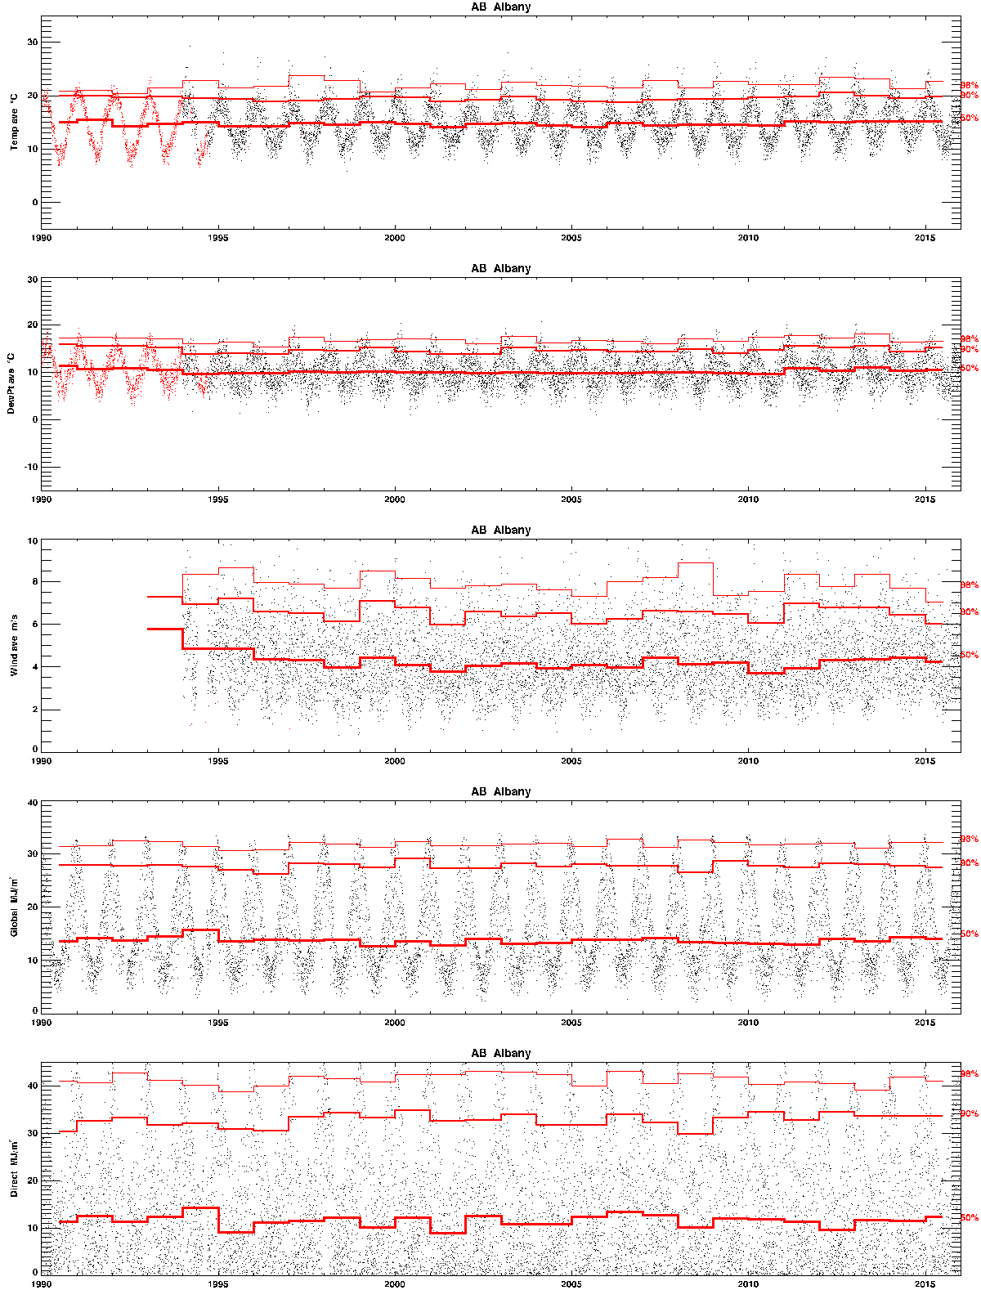

As above for **Adelaide**.

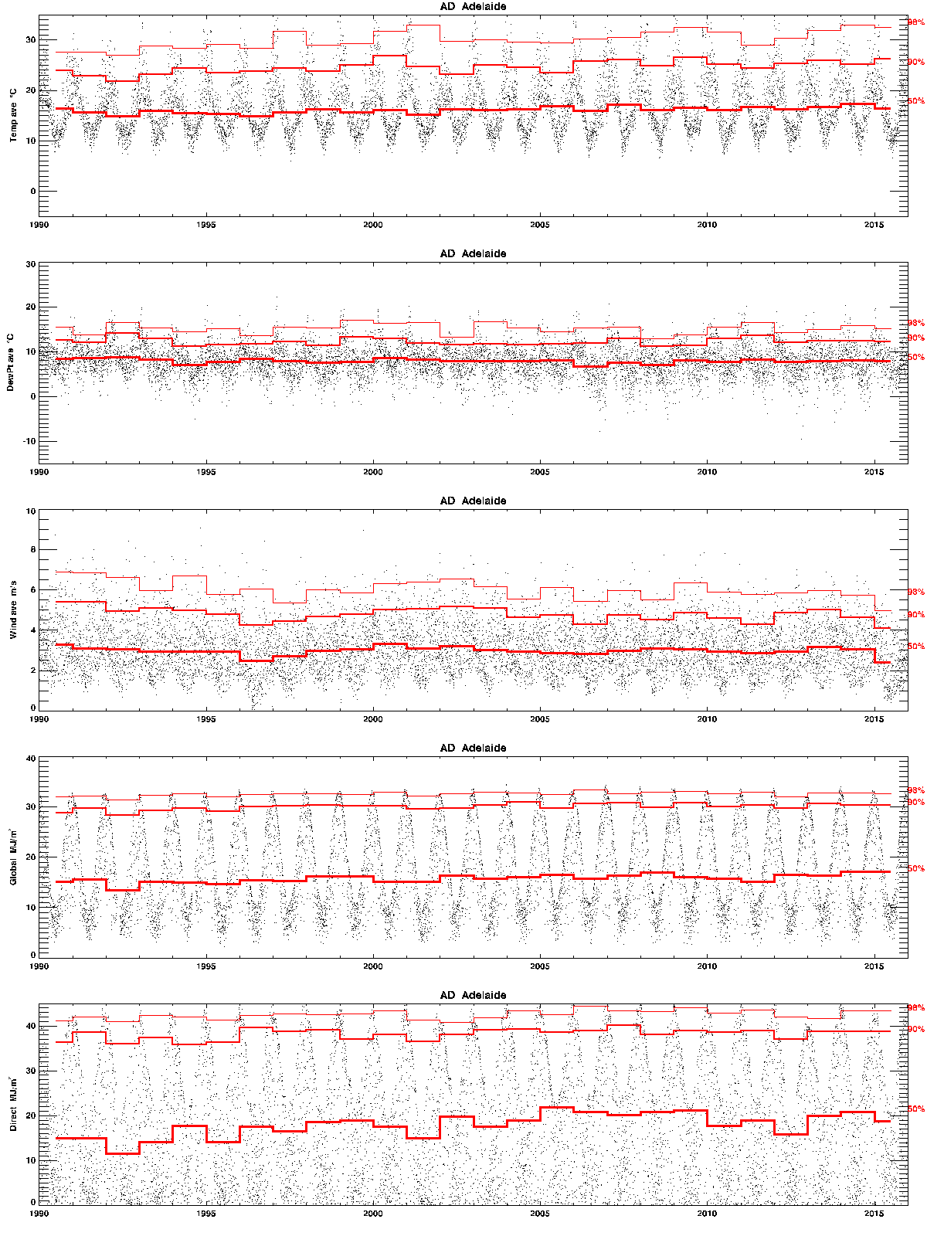

As above for **Ballarat**.

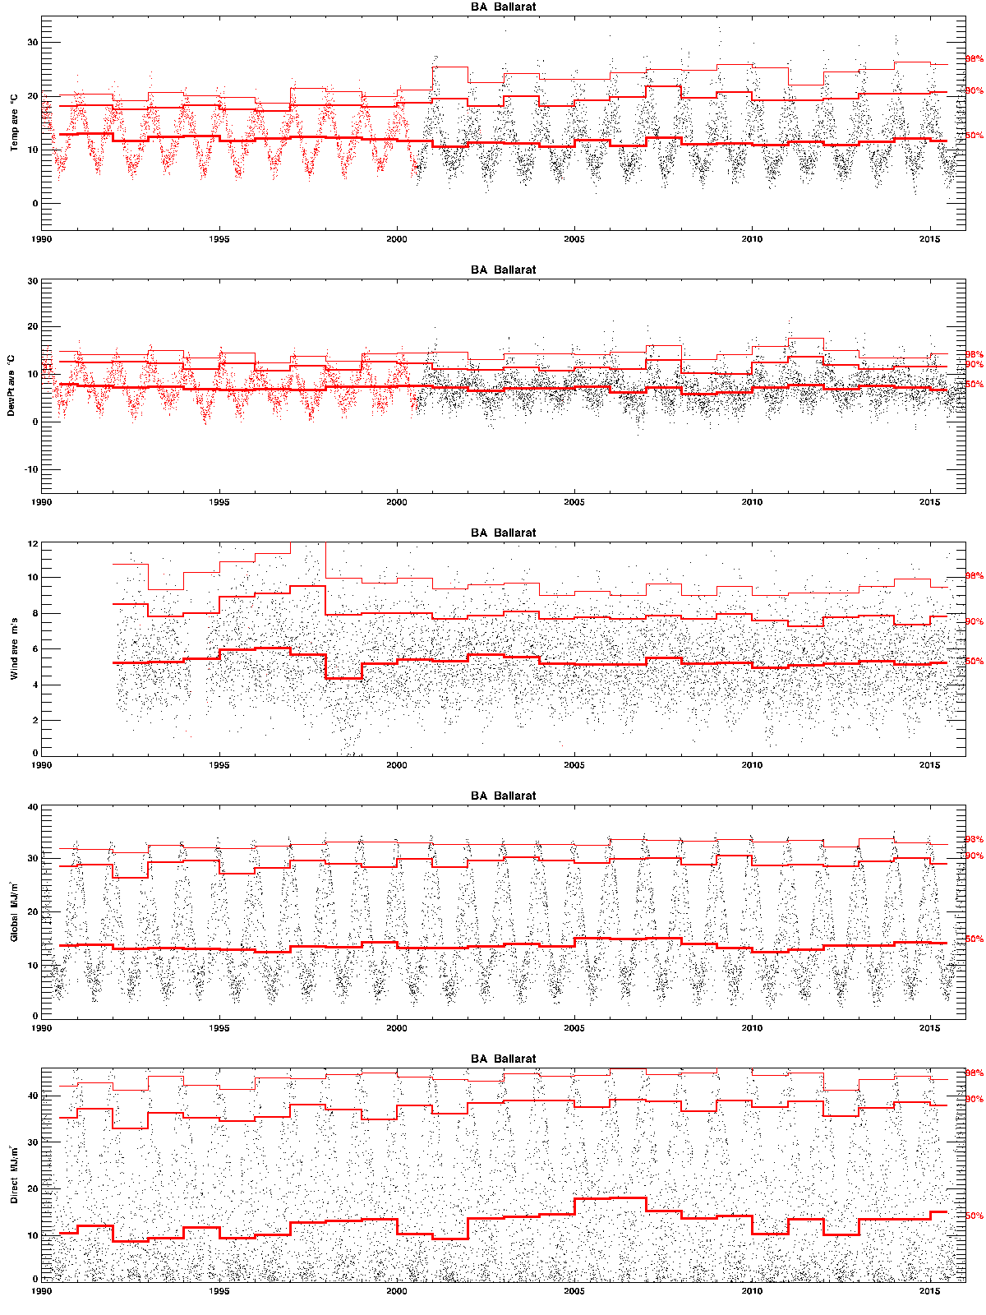

As above for **Brisbane**.

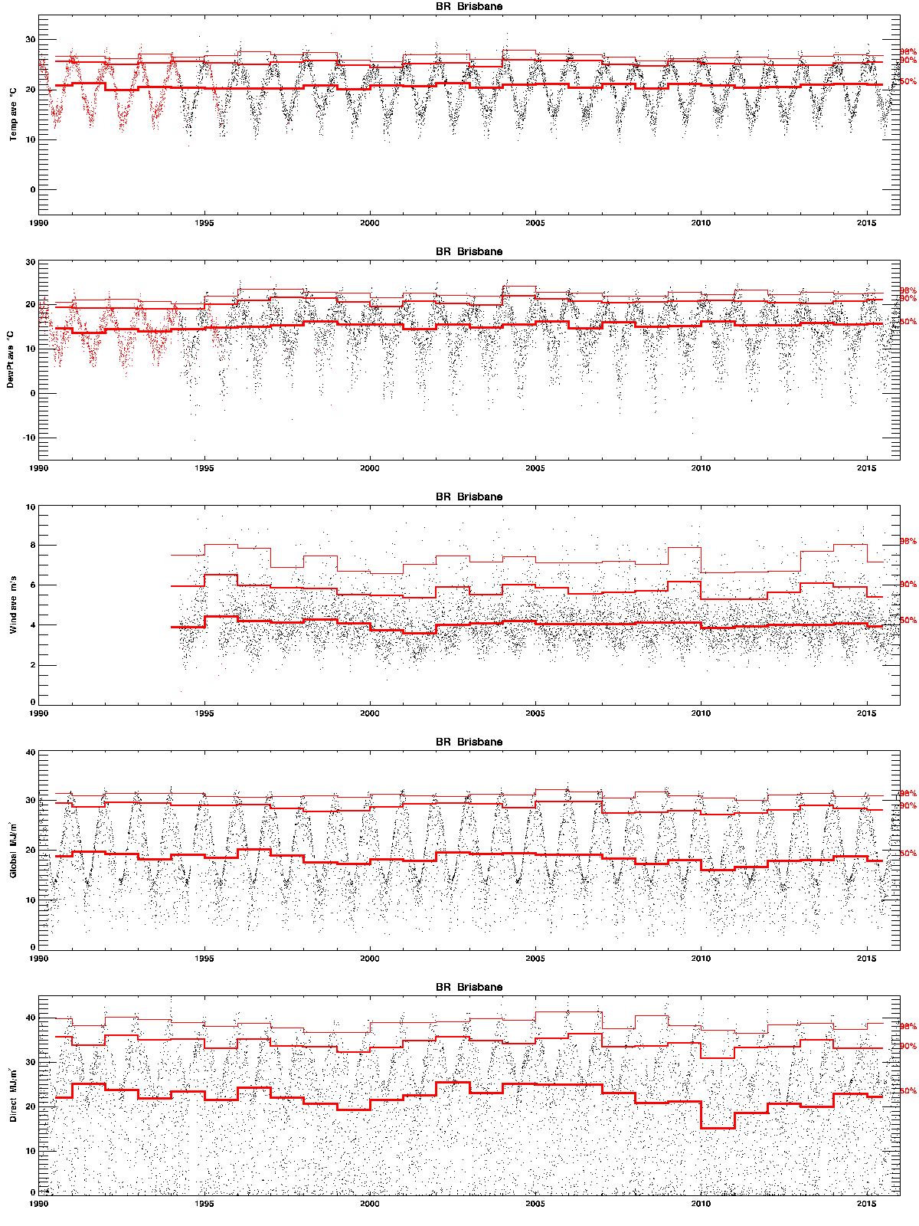

As above for **Canberra**.

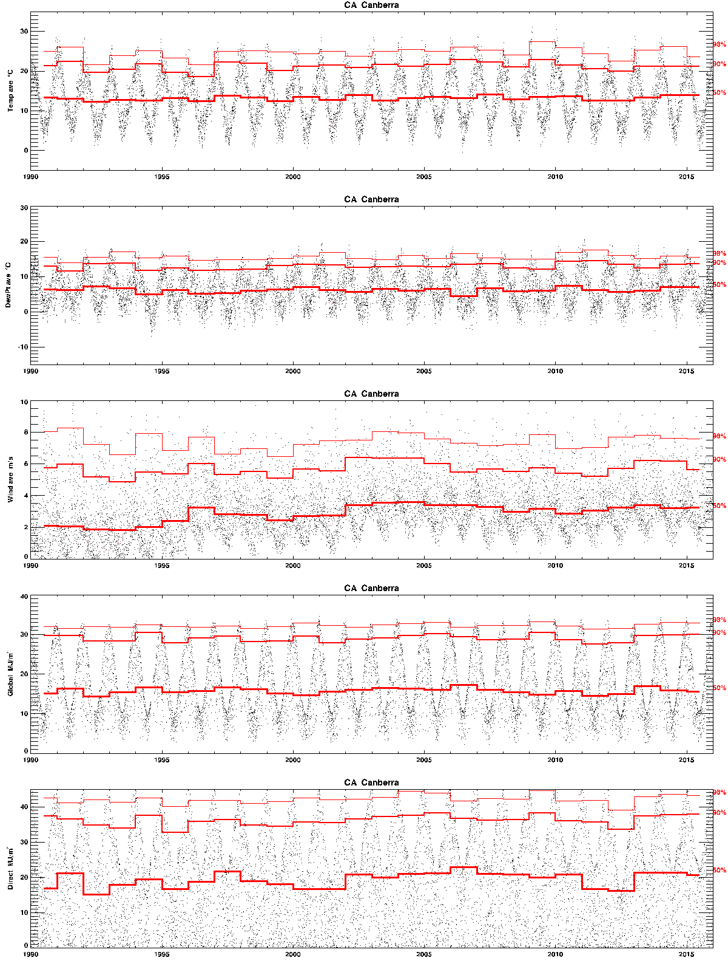

As above for **Christmas Island**.

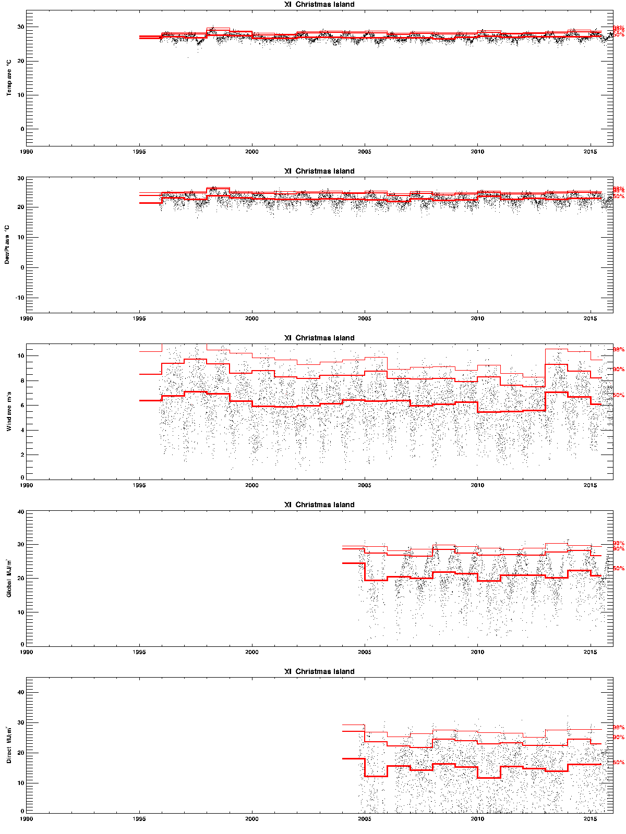

As above for **Darwin**.

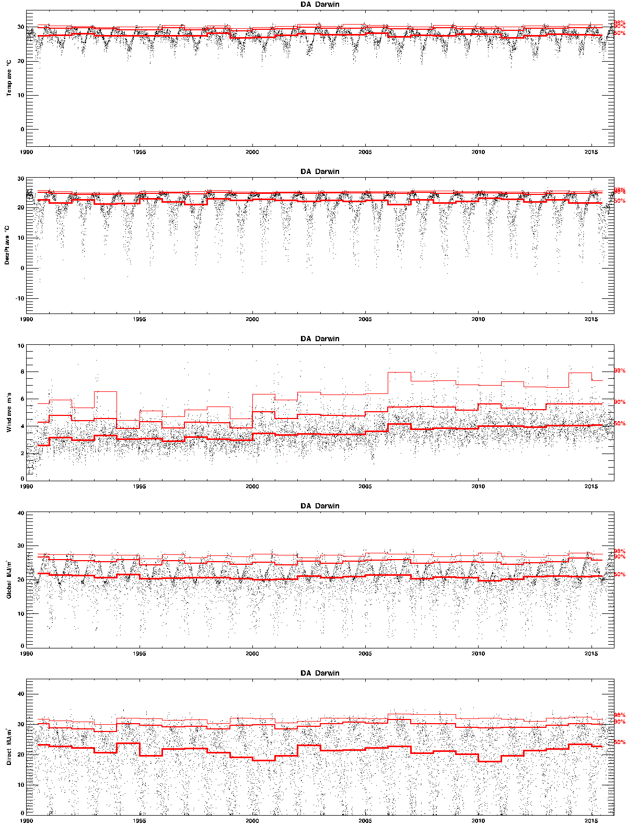

As above for **Glasshouse Mountains**.

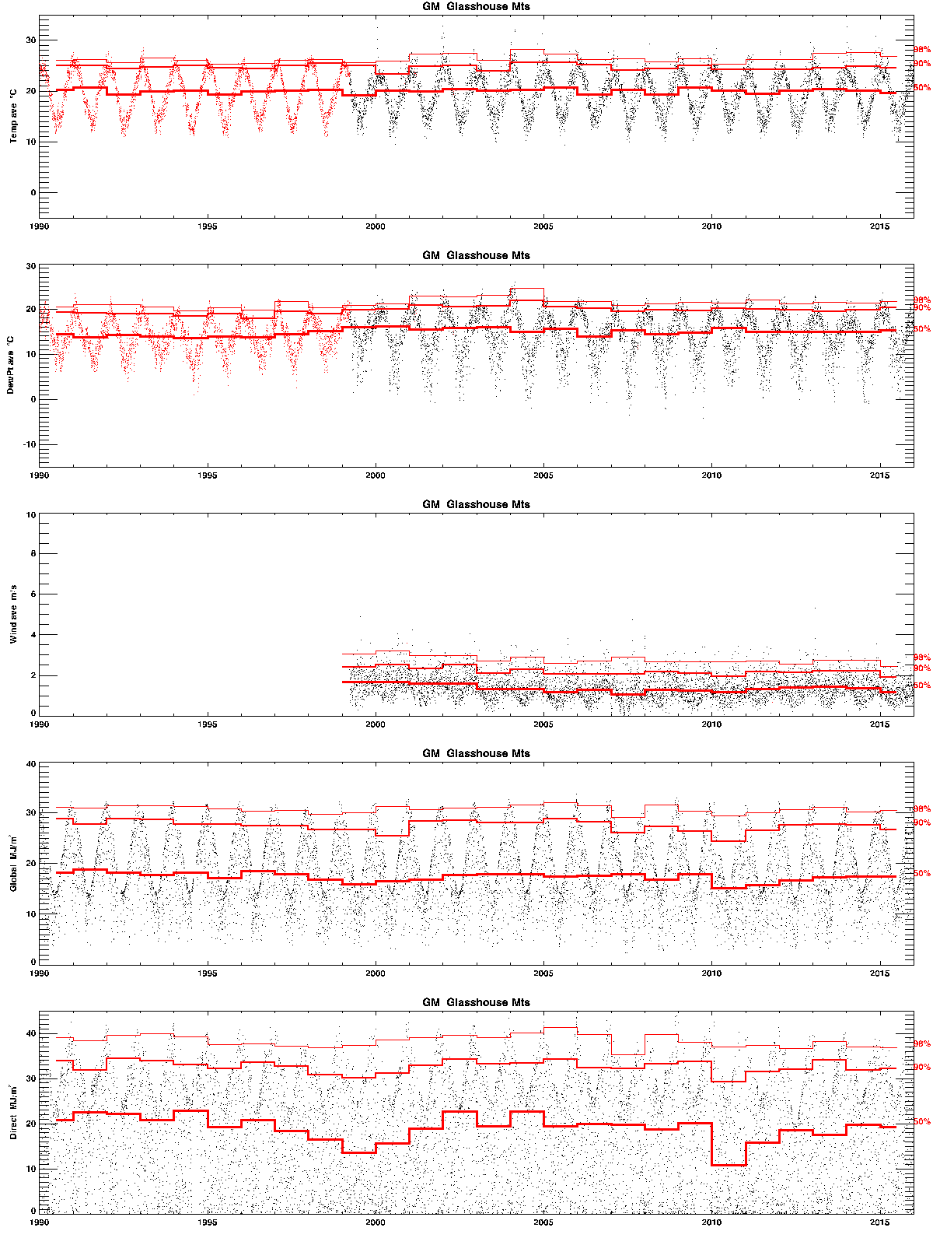

As above for **Maleny**.

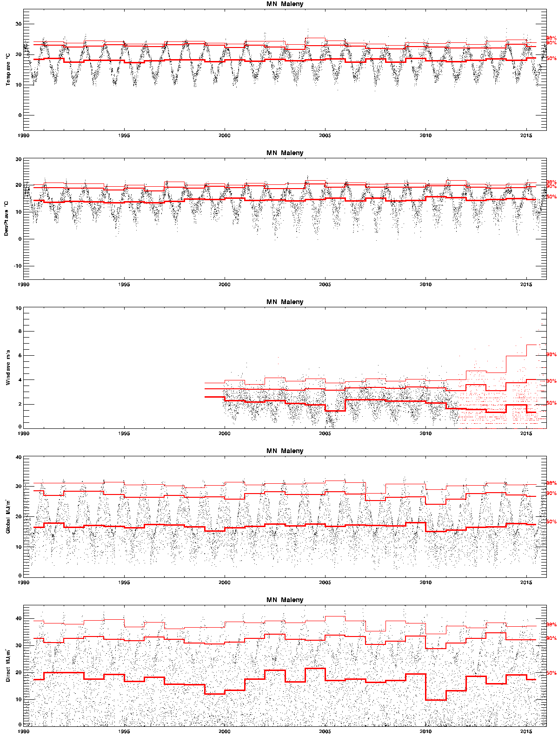

As above for **Melbourne RO**.

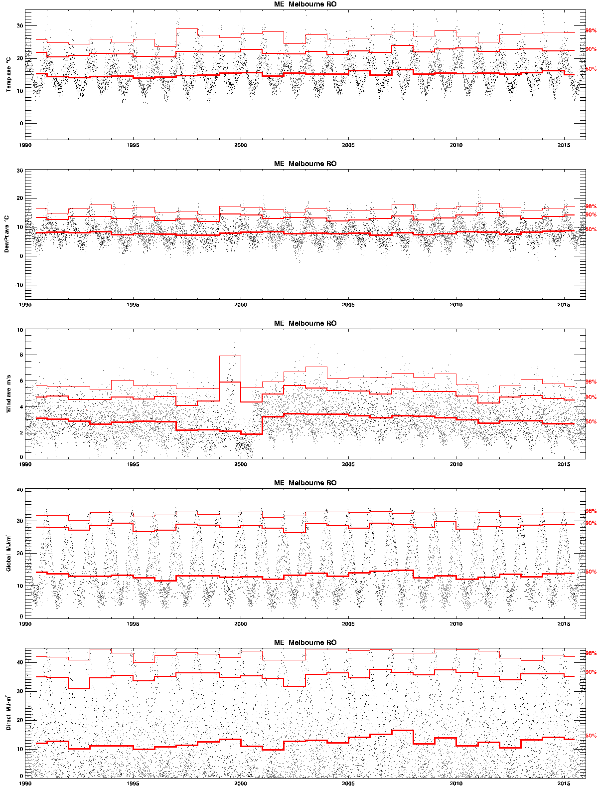

As above for **Richmond**.

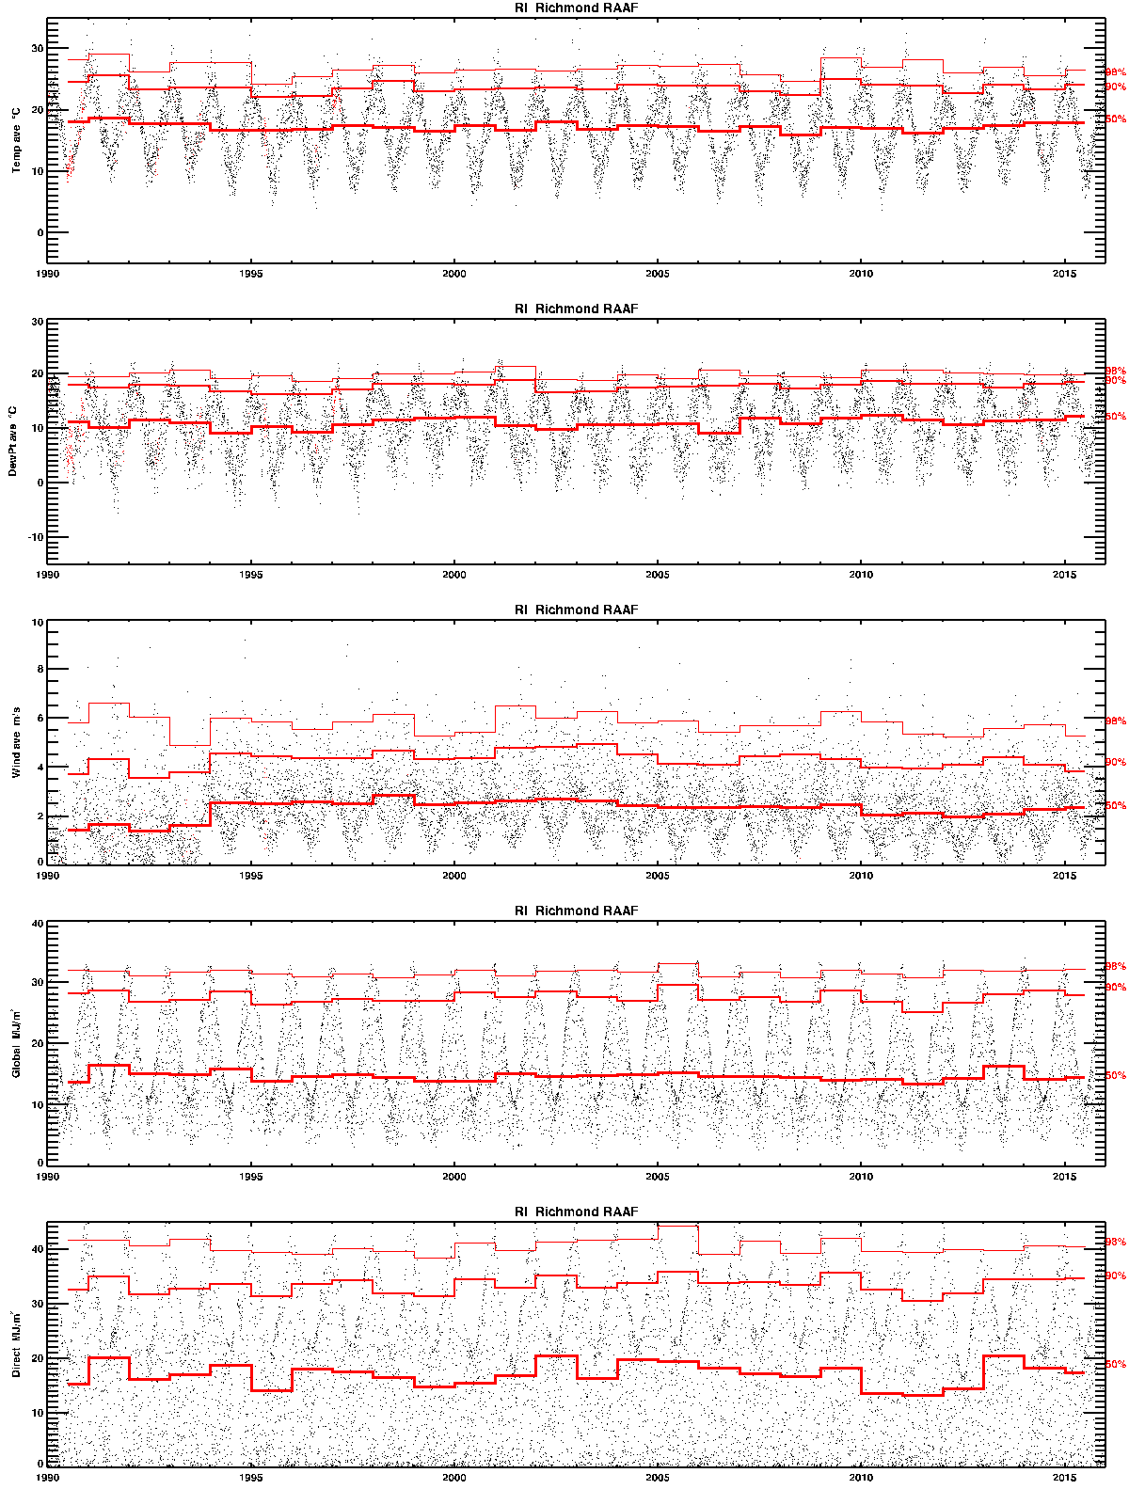

As above for **Rockhampton**.

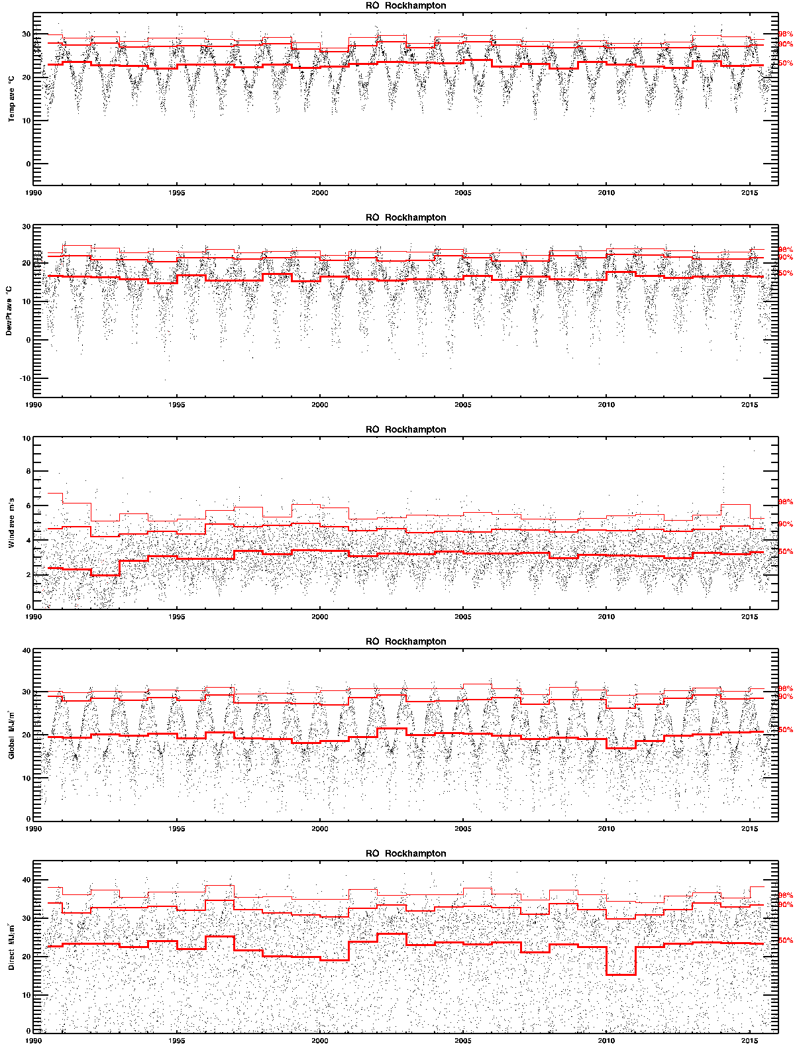

As above for **Sydney**.

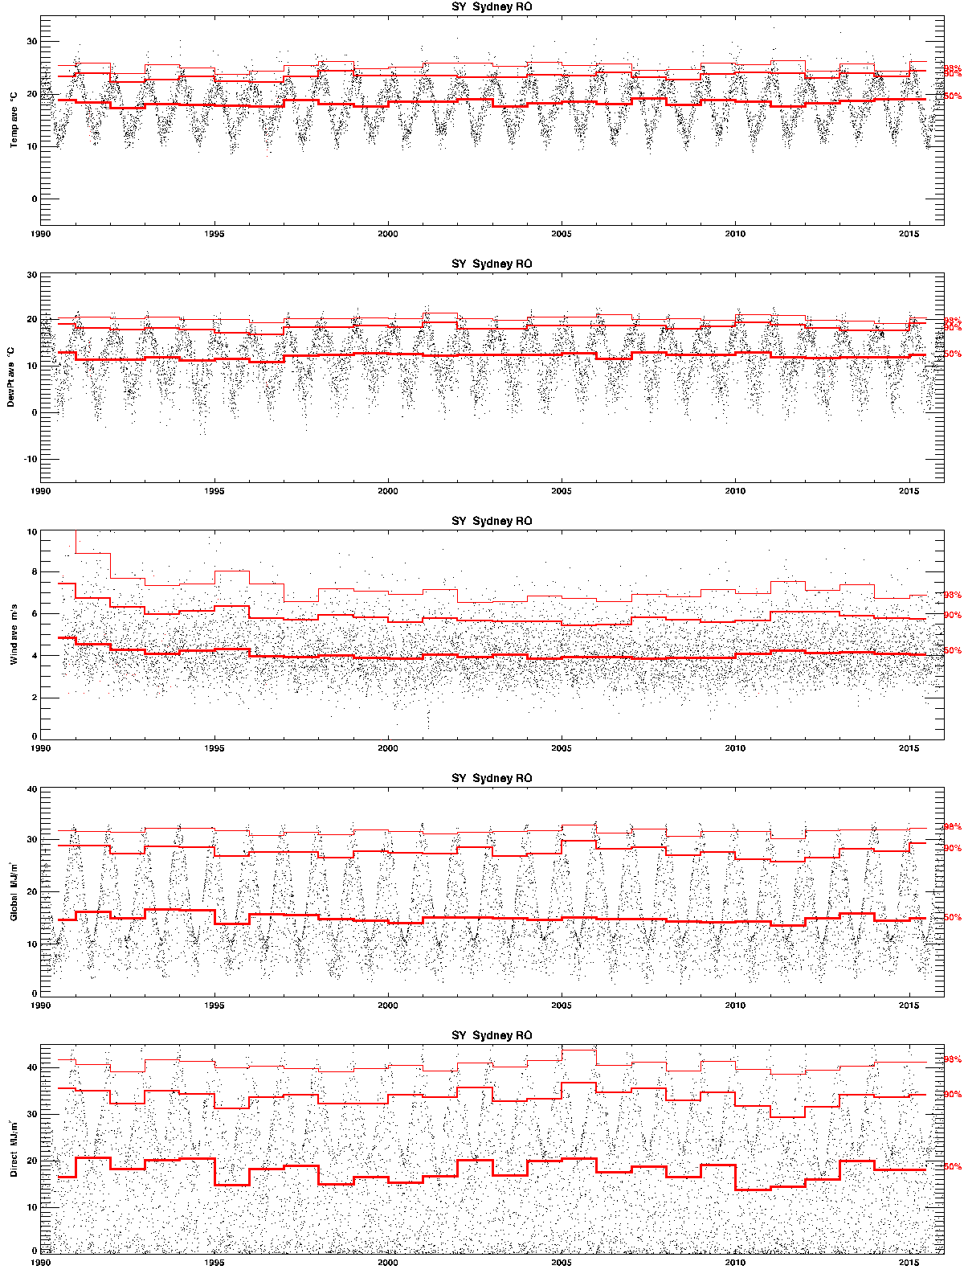

As above for **Willis Island**.

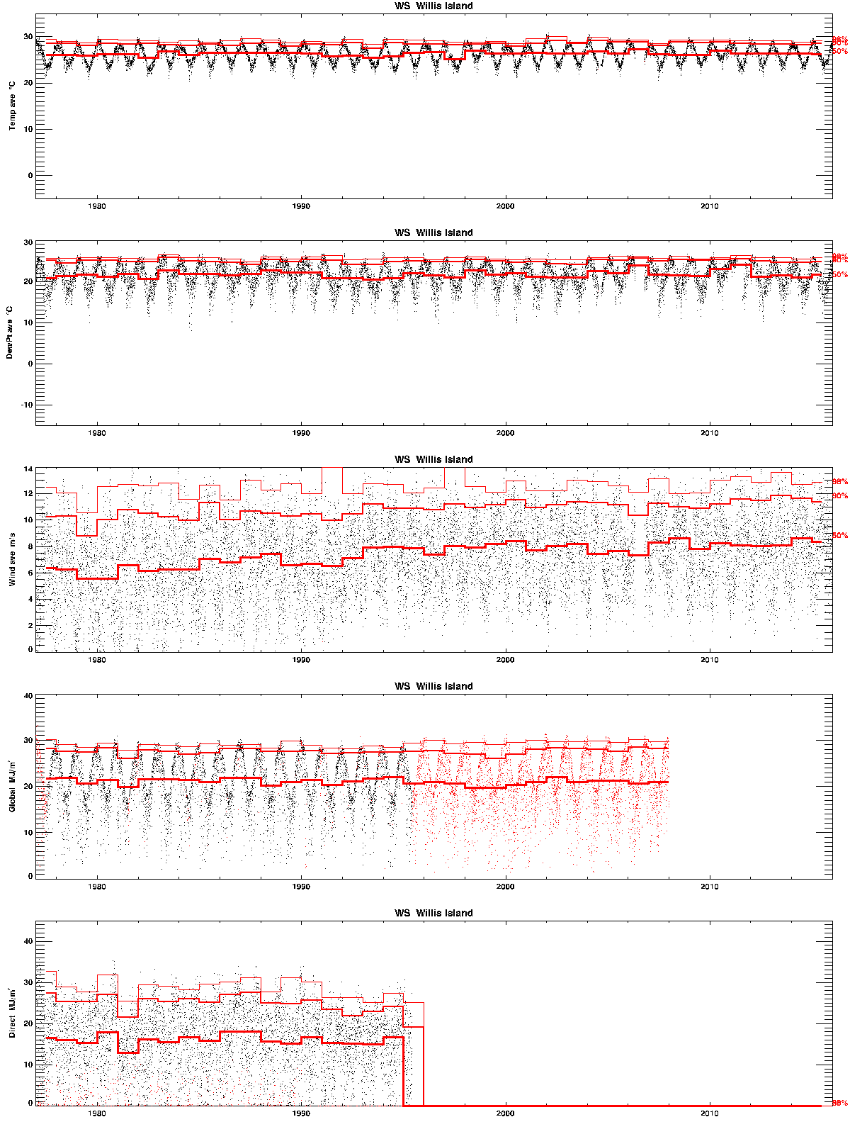

Appendix B Mathematical details of TMY2/RMY selection

Finkelstein-Schafer statistic

The statistic for closeness of a month’s data to the mean distribution is:



where

1.  is the value of parameter *x* on day *d*
2.  is the distribution of parameter *x* in month *m* of year *y* (black, **Error! Reference source not found.**)
3.  is the combined distribution of parameter *x* in month *m* (red, **Error! Reference source not found.**)
4.  is the number of days in month *m* of year *y* with valid data.

An advantage of the F-S statistic is that, as a mean in probability space, it is dimension-free. Thus, it is directly comparable between different physical measures, so that a weighted sum of the F-S statistics for several quantities correctly reflects their specified importance without the need for prior normalisation. The RMY-A, -B, and -C weightings are listed in **Error! Reference source not found.**. Only the RMYA values are used in the present work.

The weights *wx* are used to compute the combined F-S statistic of each year *y* for month *m*:



Note that the F-S statistic can be computed even for months with missing data for some days, and such months still contribute sensibly to the combined distribution functions and to the sorted set of weighted F-S values. Months with some missing data are thus still of value in establishing what is ‘typical’, but at the stage of selecting years for each month of the TMY we omit any with whole days missing for any parameter.

Closeness to long-term mean or median

The next step in the prescription of Marion and Urban (1995) is to select the five months with lowest combined F-S score, and rank them in order of “closeness of the month to the long-term mean and median”. They do not say how they compare these two measures, nor how they weight them for the different parameters as both mean and median are expressed in physical units so would require some normalisation.

In past work, we explored several techniques for applying Step 2 of Marion and Urban, such as scaling the means by standard deviation and the medians by interquartile range, weighting both measures equally and then by the weights for each parameter. Our preferred technique, for consistency with Step 1, is to simultaneously compute a ‘signed’ F-S value defined, with the same notation as previously, by:



Referring to **Error! Reference source not found.**, the true *FS* measures the mean absolute deviation of a month’s distribution function from the combined distribution function, but a curve lying entirely above or below the reference curve can score equally with one that crosses it. In contrast, *FSs* is smallest for a curve that lies equally above and below the reference and will consequently have a median value close to the overall median.

The *FSs* values have the further advantages that they can be computed simultaneously with *FS* and weighted in the same way, they are again independent of physical units, and skewness of the underlying distribution is accommodated. Tests using possible measures other than *FSs* made only small changes to the order of preference among initially selected years.

Although in the end we did not use them in the selection process, means and standard deviations of daily values within a month were computed for all parameters, and they provide a useful visual check of results. Each TMY2 or RMY comes from 120 plots like **Error! Reference source not found.** (12 months x 10 parameters); all merged into F-S statistics which are not easy to review. Instead we show, in Appendix C, several examples of monthly means and standard deviations of solar radiation, temperature, humidity, and wind speed, with the selected months highlighted.

For convenience of comparison, the same scales are used for the corresponding plots in Appendix C, though this does put some data points off scale. Months chosen for inclusion in the TMY should be central for both mean and standard deviation, and this for all four variables. That objective is not fully achievable; the most typical months for mean radiation might be extreme for its variability, or for temperature or wind, for example. Appendix C shows that the TMY2/RMY procedure produces reasonable results.

Persistence of high or low values

In their Step 3, Marion and Urban (1995) prescribe that “persistence of mean dry bulb temperature and daily global horizontal radiation are evaluated by determining the frequency and run length above and below fixed long-term percentiles.” They use both terciles (33rd and 67th percentiles) for temperature, and the lower tercile for radiation. Applying the persistence criteria to candidate months from Step 2, they exclude “the month with the longest run, the month with the most runs, and [any] month with zero runs.” The implication of this description is that the most and least persistent of just the candidate months are excluded, without reference to whether those months are more or less persistent than usual for the long-term record. If, for example, all five months are more persistent in weather patterns than the long-term average, then surely the least persistent of those five should be preferred.

Marion and Urban (1995) are also less than clear what constitutes a ‘run’, but two consecutive values in the same tercile (high, medium, or low temperature; or low radiation or not) seems to be the criterion. This gives three separate run measures, and the question of whether they are to be tested separately or in combination. Do few runs for high temperature compensate for many runs of low radiation? With some difficulty interpreting the prescription, we adopted the following technique.

Histograms of sequential days within the above terciles are computed, and their cumulative sum gives the distribution function of run lengths of each type, analogous to **Error! Reference source not found.**. The combined distribution of run lengths enables evaluation of each month’s distribution, as previously, with an FS-type statistic, *FSr* say.



where

1.  is the cumulative number of runs of length *l* in month *m* of year *y* for test *t* (parameter and tercile criterion)
2.  is the weighted sum of the 
3.  is the mean of  across all years.

For similarity to the earlier weightings for the 10 parameters, we separately considered runs of low global or direct radiation, and then with equal weightings *wt*. The distribution of these *FSr* statistics across all years at several sites shows a long tail of high values in less than about 10% of cases. Selection of TMY-month years was thus restricted to below the 90th percentile for *FSr*.